Hex Dump and disassemble

Convert .elf file to raw hex

Command- riscv32-unknown-elf-objcopy -O ihex hello.elf hello.hex

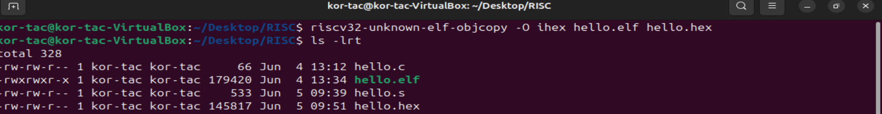

**Explanation:**

* -O ihex: Output format is Intel HEX (can be used to load into memory of boards/emulators).
* hello.elf: Input ELF file.
* hello.hex: Output HEX file.

Disassemble the .elf file using objdump

Command- riscv32-unknown-elf-objdump -d hello.elf > hello.dump

* -d: Disassemble all executable sections.
* -S: Mix in source code if debug info is available (-g during compile).
* > hello.dump: Save output to a file.

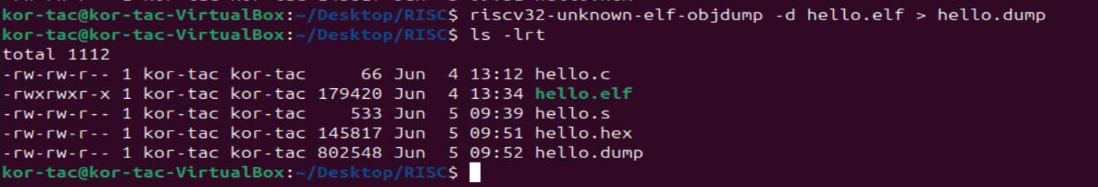

Opening the .hex file

Command- cat hello.hex

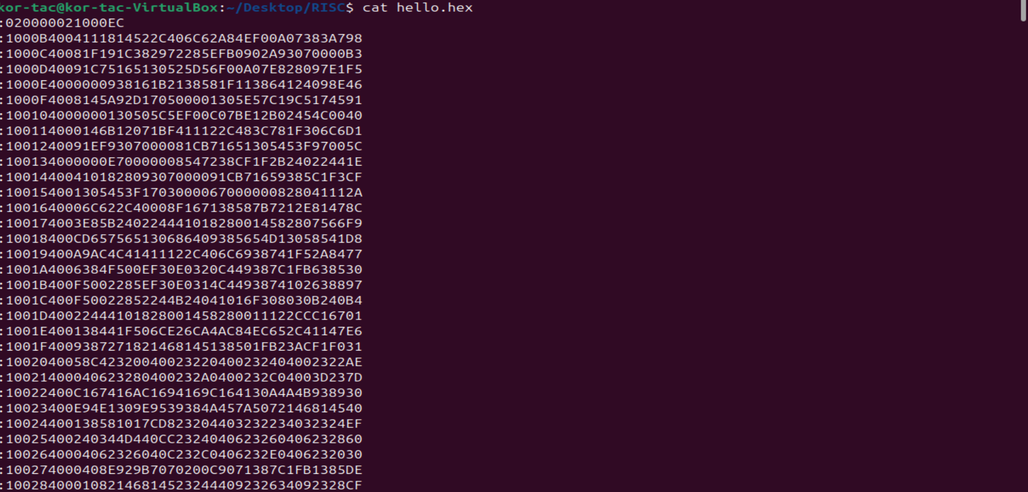

Open the hello.dump file and locating the main function

Command- grep -A 20 “<main>:” hello.dump

